JOE BOLKCOM  STATE SENATOR  Forty-third District  Statehouse: (515) 281-3371  __  HOME ADDRESS  1235 Oakes Dr.  Iowa City, IA 52245  Phone: (319) 337-6280  joe@joebolkcom.org  joe.bolkcom@legis.iowa.gov  www.joebolkcom.org | 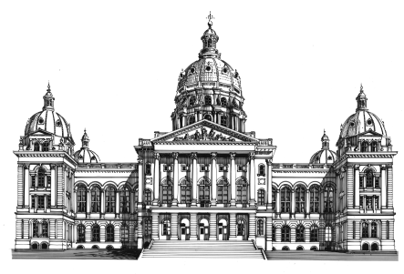  The Senate  State of Iowa  Eighty-seventh General Assembly  STATEHOUSE  Des Moines, IA 50319 | ASSISTANT DEMOCRATIC LEADER  COMMITTEES  Appropriations, Ranking Member  Human Resources  Ways and Means  Health and Human Services  Appropriations Subcommittee
Open letter to Governor Reynolds

Dear Governor Reynolds:

Today, you will have an opportunity to speak one-on-one with President Trump in Cedar Rapids.

I support your announced plan to raise the issue of Iowa’s failing individual insurance market. However, that issue is only one part of Iowa’s health care problems.

Governor Reynolds, you must be aware that the Republican-controlled U.S. Congress is rushing to send President Trump health care legislation. This legislation will devastate Iowa families, Iowa health care providers, the State of Iowa’s budget, and the Iowa economy.

That’s why Iowans are counting on you to convince President Trump to oppose this impending disaster. Here are some of the reasons why the Republican health care bills are so bad for all Iowans:
- Proposed cuts to Medicaid expansion threaten health care for 150,000 Iowans.
- More Iowans will be living without health insurance. There will be more uninsured charity care, care that is less effective, more costly, and will increase everyone’s health care costs.
- Older Iowans, who make up an increasingly large share of Iowa’s population, will be hit especially hard by these changes.
- Cuts, caps or block granting federal Medicaid spending will cost the state of Iowa hundreds of millions of dollars.
- Health care providers will be paid less. It will be harder to recruit and keep qualified doctors, nurses and other caregivers, especially in Iowa’s small towns and rural communities.
- Health care is a large part of Iowa’s economy. Health care layoffs and wage cuts will hurt all sorts of Iowa businesses and weaken our economy.

Iowa’s response must be bipartisan. That’s why at tomorrow’s meeting of the Legislative Council, I will propose that we create a special legislative interim committee to examine Iowa’s health care crisis and offer solutions.

This committee would look at proposed Medicaid cuts, the collapse of the individual market, the repeal of the Affordable Care Act, and the impact on the state budget.

Governor Reynolds, please use your influence with President Trump to make sure Iowans can keep their health insurance, to protect rural hospitals and health care providers, and to prevent a devastating blow to Iowa’s economy.

I hope you will return to Des Moines with some good news. We need some right now.

Signed,

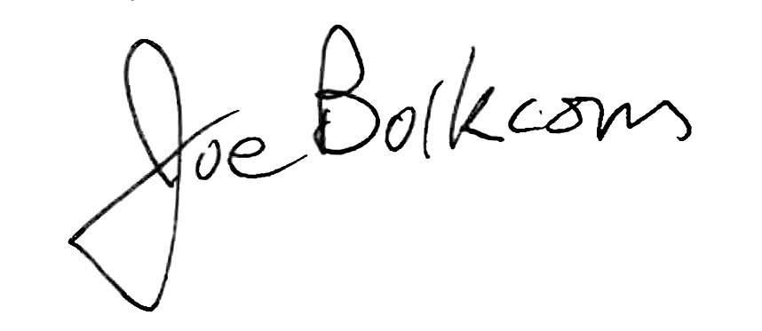

Joe Bolkcom
State Senator

